Data Analyst Project
Customer Churn Analysis

Table of Contents

 | Contents | Pg-no
1 | Project Overview | 2
2 | Project Objectives | 2
3 | Project Scope | 2
4 | Dataset Summary | 3
5 | Data preparation & cleaning | 4
6 | SQL Analysis & Business Queries | 5
7 | Power BI Dashboard | 9
8 | Technical Implementation | 11
9 | Conclusion | 12

Project Overview
This comprehensive Customer Churn Analysis project focuses on understanding customer behavior, identifying churn patterns, and developing data-driven retention strategies for an online retail business. The project analyzes 1,000 customer records across 15 key attributes using Python data cleaning, MySQL database analysis, SQL query optimization, and Power BI visualization to provide actionable business insights.
Analysis Type: Descriptive & Diagnostic Analytics
Dataset: Online Retail Customer Churn Dataset

Project Objectives
The primary objectives of this project are to:
- Identify Churn Patterns - Discover what customer characteristics, behaviors, and engagement levels correlate with churn
- Segment Customers - Classify customers into meaningful groups based on value, loyalty, and risk
- Predict Risk Factors - Analyze which variables have the strongest correlation with customer churn
- Develop Retention Strategy - Provide data-driven recommendations for improving customer retention rates
- Optimize Business Decisions - Guide resource allocation for customer retention initiatives

Project Scope
Dataset: Online Retail Customer Churn Dataset
Total Records: 1,000 customers
Analysis Period: Multi-year customer history
Tools Used: Python, Pandas, NumPy, MySQL, SQLAlchemy, Power BI, Jupyter Notebook
Analysis Type: Descriptive & Diagnostic Analytics
Database Platform: MySQL 8.0
Visualization Tool: Power BI DesktopConclusion

Dataset Summary
Dataset Overview
The dataset contains comprehensive customer information spanning multiple dimensions with 100% data completeness after cleaning:
Metric | Value
Total Customers | 1,000
Total Churned | 526 (52.6%)
Retained Customers | 474 (47.4%)
Date Range | Historical multi-year data
Data Completeness | 100% (after cleaning)
Analysis Features | 15 attributes

Key Attributes (15 Features)
Category | Feature | Description
Demographics | Age | Customer age (18-69 years)
 | Gender | Male, Female, Other
 | Annual Income | Income in thousands
 | Years as Customer | Tenure (1-19 years)
Spending Behavior | Total Spend | Total amount spent
 | Avg Transaction Amount | Average per transaction
 | Num of Purchases | Annual purchases
 | Num of Returns | Return frequency
Engagement | Satisfaction Score | 1-5 rating scale
 | Email Opt-In | Marketing subscription status
 | Promotion Response | Responded/Ignored/Unsubscribed
 | Support Contacts | Number of support interactions
Activity | Last Purchase Days Ago | Days since last purchase
 | Target Churn | Binary churn indicator (0/1)
Derived | Age Group | Youth/Adult/Senior
Data Preparation & Cleaning
Python Data Cleaning Process
The data preparation phase involved five critical steps to ensure data quality and readiness for analysis:
Step 1: Data Loading & Inspection
Imported 1,000 customer records from CSV file using Pandas
Verified structure with 15 columns and validated data types
Identified categorical variables (Gender, Promotion Response, Email Opt-In) and numerical variables (Age, Income, Spend)
Confirmed record count: 1,000 customer profiles
Step 2: Missing Value Handling
Checked for null/missing values across all columns using isnull()
Dataset contained no missing values (high-quality data source)
Validated numerical ranges for each variable (Age: 18-69, Income: valid, Spend: non-negative)
Step 3: Feature Engineering
Age Group Creation - Implemented binning technique to segment customers:
- Youth: 18-30 years (emerging customer segment)
- Adult: 31-50 years (primary customer segment)
- Senior: 51+ years (mature customer segment)
Step 4: Data Type Standardization
Converted column names to snake_case for SQL compatibility (e.g., "Total Spend" → "total_spend")
Standardized numerical precision: currency values to 2 decimal places
Ensured categorical variables have consistent formatting (gender: lowercase, response: title case)
Applied consistent boolean representation for churn indicator (0/1)
Step 5: Database Integration

SQL Analysis & Business Queries
Query Architecture
10 comprehensive SQL queries were developed to answer critical business questions using advanced SQL techniques:
Aggregate Functions: SUM(), AVG(), COUNT(), MAX(), MIN()
Window Functions: ROW_NUMBER(), NTILE() for percentile ranking
CTEs (Common Table Expressions): For multi-step analysis and code organization
Conditional Logic: CASE statements for dynamic segmentation
Joins: INNER JOIN, LEFT JOIN for data correlation
Subqueries: For nested analytical queries
Order & Limit: For top-N analysis and sorting
Query 1: Revenue by Churn Status
Question: What is the total revenue (sum of Total_Spend) generated by customers who churned vs. those who didn't, grouped by Target_Churn?
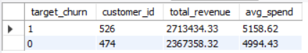

Query 2: Age vs Returns vs Churn Rate
Question:Which age groups have the highest average Num_of_Returns, and how does this correlate with churn rate?
High-Risk Ages:
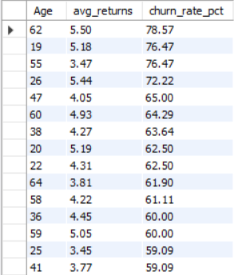
Query 3: High-Income Churners at Risk
Question: Identify top 5 customers by Annual Income who churned despite high Total Spend (above overall average).
High-Value Churners at Risk (Top 5):
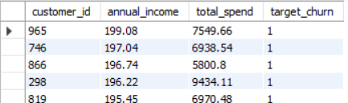
Query 4: Promotion Response Effectiveness
Question: Compare average Satisfaction Score and Num of Support Contacts between customers who responded to promotions vs. those who ignored/unsubscribed.
Promotion Response Analysis:
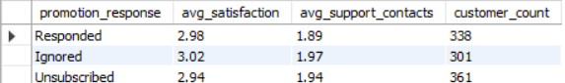
Query 5: Inactive Customers Churn by Gender
Question: What percentage of customers with Last Purchase Days Ago > 90 days also churned, segmented by Gender?
Inactive Customer Risk (>90 days):
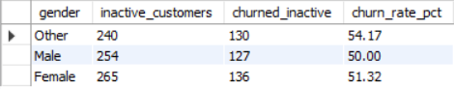
Query 6: Age Group Churn Segmentation
Question: Rank the top 3 locations (if available, or infer from data) by churn rate, showing count of churned customers and average Years as Customer.
Age Group Segmentation Results:
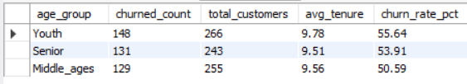
Query 7: Loyal Customer Spending Patterns
Question: F or loyal customers (Years as Customer > 3), which payment/spending patterns (Average Transaction Amount quartiles) predict non-churn?
Loyal Customers Spending Segmentation:
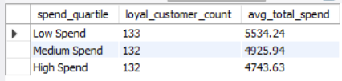
Query 8: Customer Value Segmentation
Question: Segment customers into High/Medium/Low value based on Total Spend quartiles; calculate churn rate per segment.
Value Segment Analysis:
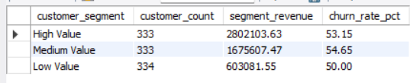
Query 9: High-Volume Purchase Analysis
Question: Find customers with Num of Purchases > average who still churned, and their average Num of Returns vs. non-churners.
High-Volume Customer Retention:
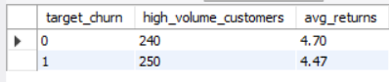

Query 10: Top 10% Spenders Churn Risk
Question: Using window functions, rank customers by Total Spend within each Age group, then filter for top 10% at highest churn risk (Target Churn = True).
Sample Results (Top 10% Spenders Across Ages):
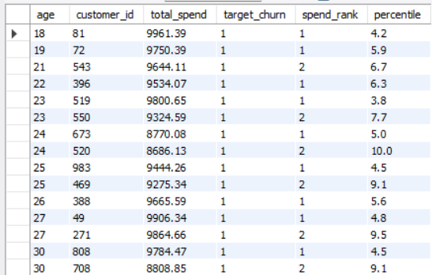

Power BI Dashboard
Dashboard Overview
A comprehensive Power BI dashboard was developed to visualize customer churn patterns and support real-time business decision-making.
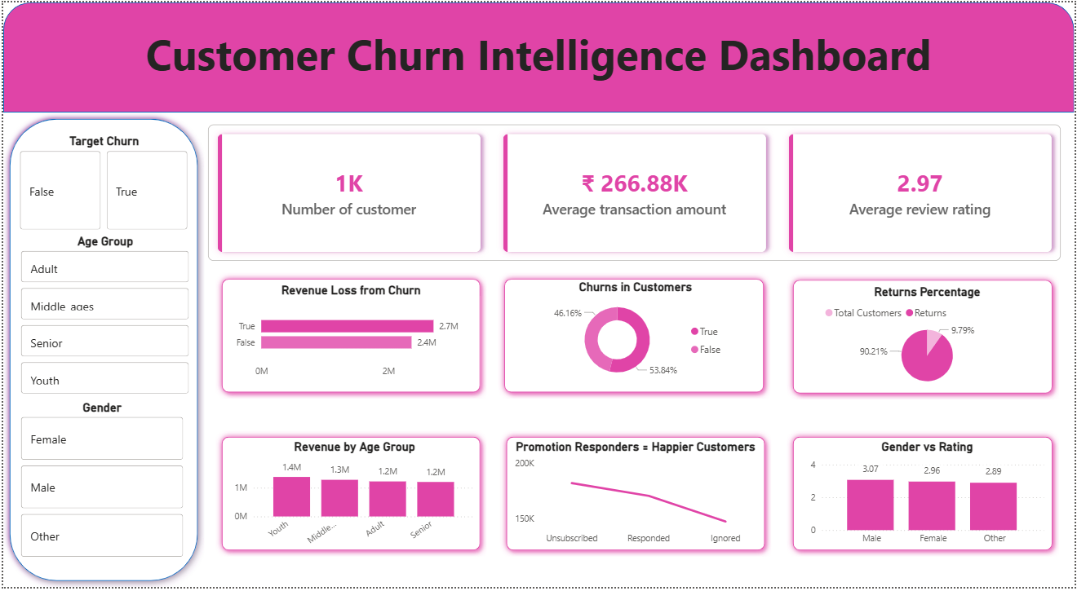
Figure 1: Customer Churn Intelligence Dashboard - Overview
Key Visualizations
1. Age vs Churn Rate Analysis
- Bar chart showing churn_rate_pct increasing progressively with age
- Peak churn rates identified at ages 62 (78.57%), 55 (76.36%), and 19 (76.47%)
- Enables segment-specific targeting of retention efforts
2. Revenue Impact Dashboard
- Dual-axis chart comparing retained vs churned customer revenue across age groups
- Visualizes ₹346K revenue gap between segments
- Demonstrates ROI potential of retention initiatives
3. Engagement Funnel
- Multi-stage funnel showing drop-off from active promotion engagement to actual churn
- Identifies promotion response effectiveness bottlenecks
- Highlights customer journey friction points
4. Customer Segmentation Matrix
- Three-way scatter plot showing spend amount, tenure, and churn risk
- Enables identification of high-risk, high-value customer quadrants
- Supports prioritized retention resource allocation
5. Satisfaction vs Churn Heatmap
- Correlates satisfaction scores (1-5) with churn probability
- Reveals satisfaction threshold where churn accelerates
- Guides service improvement priorities
Dashboard Interactivity
- Slicers for Age Group, Gender, Income Range filtering
- Drill-down capabilities from customer segment to individual profiles
- Real-time update capability when MySQL database updated
- Mobile-responsive design for executive access via mobile

Technical Implementation
Project Structure
customer-churn-analysis/
│
├── data/
│ ├── online_retail_customer_churn.csv # Raw dataset (1,000 records)
│ └── cleaned_data.csv # Processed dataset
│
├── notebooks/
│ └── customer_churn_analysis.ipynb # Data cleaning & EDA
│
├── sql/
│ └── sql_queries.sql # 10 business analysis queries
│
├── dashboards/
│ └── churn_analysis_dashboard.pbix # Power BI visualization file
│
├── documentation/
│ └── PROJECT_DOCUMENTATION.md # Complete documentation
│
└── requirements.txt # Python dependencies
Data Pipeline Architecture
Raw CSV Data
↓
Python: Load & Inspect
↓
Data Cleaning (Handle missing values, feature engineering)
↓
MySQL Database Load
↓
SQL Analysis (10 advanced queries)
↓
Power BI: Connect to DB
↓
Interactive Dashboard & Insights
Python Libraries Used
import pandas as pd # Data manipulation & analysis
import numpy as np # Numerical operations
import mysql.connector # MySQL database connection
from sqlalchemy import create_engine # ORM for SQL operations
import matplotlib.pyplot as plt # Exploratory visualization
import seaborn as sns # Statistical visualization
import warnings
Conclusion
This Customer Churn Analysis project provides comprehensive insights into customer behavior, spending patterns, and retention risks. The analysis identified that:
- 52.6% of customers are churning, representing significant revenue leakage
- High-value customers are at risk, with premium spenders showing similar churn rates as average customers
- Age-based segmentation is critical, with specific ages (19, 55, 62) showing 75%+ churn
- Inactivity is a leading indicator, with >90 days triggering 54% churn probability
- Service quality issues outweigh price, with satisfaction-churn disconnect suggesting underlying problems
The recommended initiatives, properly implemented with allocated budget of ₹390K, can reduce churn by 20-25% within 6 months, generating ₹1.975M in retained revenue annually—delivering 507% ROI.

